

**Week 6, Term 4, 20 November 2024**

**Kia ora, talofa lava, malo e lelei, 问候, namaste, 인사,** 拝啓**, mabuhay, bem vindo, fakalofa lahi atu, kia orana, kohomada, bula vinaka, huān yin, foon ying, marhaba, oso oseyo, olà, bonjour, sawadee ka, ia orana, welcome!**

# Raffle Tickets

Last day for raffle returns today!

Wow, what an amazing response to the raffle we’ve had! I know just a few of you are yet to return your books. Please can you bring these (sold or unsold!) to school today. (Wednesday).

We have some audit responsibilities so the return is important

How to return;

1. Drop your book (sold or unsold) to our raffle collection table at the Chandler Rd school entrance before or after school tomorrow. You can pay by cash, EFTPOS or Paywave. OR,
2. Send the book to school with your child for them to bring to us and you can pay for any sold tickets via direct debit to the ROPS Parent Group account: 12-30610190518-00. Please put child's name and class in reference and particulars.

Remember to make sure every sold ticket stub has a name and contact details on it. The draw is happening THIS Friday morning, with our friendly local police constable present. Good luck!

We’re on track to raise $10,000 from this raffle which is so important for us. Every dollar goes straight to the school to help fund our amazing teaching programmes and we couldn’t do it without your fundraising help. So a VERY heartfelt thank you.

# Tea Towels – Available for Purchase Now!

**Remember to check in with Louise at the office to get your limited edition tea towel/s!!!**

**They make great Christmas gifts – only $15 each.**

**Be in quick as they are guaranteed to sell out fast!**

# Whānau Fun Day

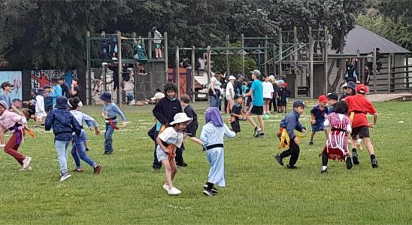Last Monday all the children had a lovely time mixing with others from their whānau group. The leaders had prepared lots of fun, active challenges for them to participate in, e.g. egg and spoon race, rippa tag, gymnastics, dodge ball, obstacle course and lots more. The students were mixed across the year groups, and it was wonderful to see the older children supporting the younger ones as they had a go at the physical tasks. The field was a sea of colour with all the tamariki dressed in their whānau colours. A big thank you to our

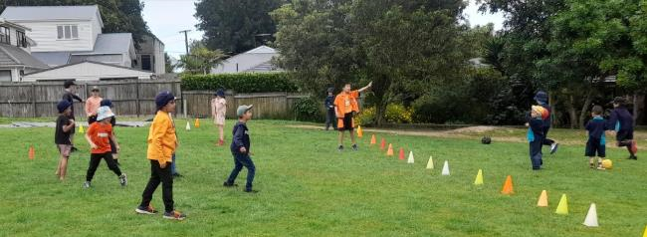Year 6 Whānau Leaders for arranging and running this great afternoon – Jessica, Eileen, To’a, William, Alex, Mischa, Summer, Carolyn, Grace, Caleb and Isla – and to the other Year 5 and 6 Sports leaders and students who supported them in running the activities. Special thanks, also, to Whaea Kirstie for supporting this group to run such a successful event.

# Royal Oak Primary School String Programme 2025 - Applications

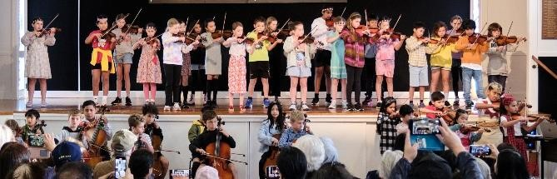We are seeking applications of interest for new beginners for the 2025 ROPS String Programme to learn Violin or Cello. We have places for 6 Beginner Violinists, and 3 Beginner Cellists.

Priority given to students in **Y3 in 2025.** Extended Application due date **Friday 29 November, 5pm**

**If interested in this opportunity for your child, please click below for information (including link to application form) CLICK HERE:** [**Royal Oak Primary School String**](https://drive.google.com/file/d/1qAoOLBQprucgVXHMbpbUQT01qcOJom_r/view?usp=sharing)

[**Programme Information 2025**](https://drive.google.com/file/d/1qAoOLBQprucgVXHMbpbUQT01qcOJom_r/view?usp=sharing)

# Teacher Only Day

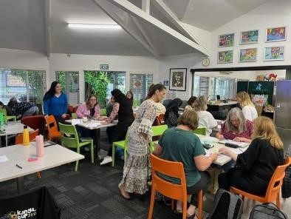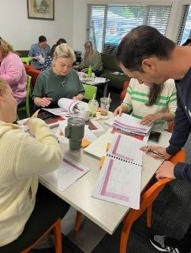Last Friday, 15 November, we held a teacher only day. The focus for the day was the teachers discussing the science of learning and becoming familiar and working with the revised mathematics curriculum document. This professional development was led by Whaea Vicky and Whaea Felicity. We had a great day of learning.

# ROPS Music Week 2024: November 25 – 29 (Next Week!)

All our ROPS musicians, and Y6 Music Leaders are all working very hard towards our annual ROPS Music Week.

Whānau and friends are warmly invited to attend Music Week Performance events to celebrate the musical learning that happens at our school. We are a school of musicians. It’s going to be a very exciting music-filled week.

**Music Week 2024 - Lunchtime Concerts**

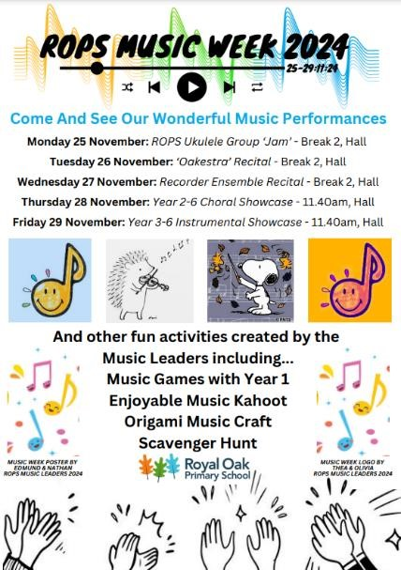

**Mon 25 Nov:** ROPS Ukulele Group ‘Jam’ - 1.00pm, Hall

**Tues 26 Nov:** ‘Oakestra’ Recital - 1.00pm, Hall

**Weds 27 Nov:** Recorder Ensemble Recital - 1.00pm, Hall

**Music Week 2024 - End-of-Year Music Showcases**

**Thurs 28 Nov - Y2-6 ROPS Choral Programme Showcase,**

**11.40am - 1.00pm, Hall**

Performances by Kapa Pasifika, Year 2 ‘Special Singers'

Choir, Year 3&4 Choir,

Year 5&6 Choir, and beautiful Classroom Music Programme Choral items with all our Y4-6 children singing.

**Fri 29 Nov - Y3-6 ROPS Instrumental Music Showcase,**

**11.40am - 1.00pm, Hall**

Performances by Ukulele Groups, ‘Oakestra’, Recorder Groups, Classroom Recorders, Handchimes Ensembles, ROPS String Programme Violins and Cellos, and a special item devised by our 2024 Music Leaders and friends.

# ROPS Ukulele Group NZ Ukulele Trust Auckland Central Ukulele Jam

On Monday 50 or so ROPS tamariki along with Whaea Annabel, Whaea Amelia, Parent Ukulele Group leader Matua Matt, and seven amazing whānau hopped on a bus to travel to the *2024 NZ Ukulele Trust Auckland Central Ukulele Jam* at Mt Roskill Primary School. It was a really fun singing and strumming alongside students from four other schools. We also all met up with Aria Clarke, a 2022 graduate student of ROPS, who was again, as in 2023, recognised at the event for her song writing skills as the NZ Ukulele Trust UkeCan-Do-It songwriting competition winner for the 2nd straight year in a row!

Many thanks to all the parent supporters who travelled with us, and those whānau who arrived at the event as audience. Huge thanks to Matt Shanks who offers his time to work with our tamariki at Monday 8am Rehearsals, and to Whaea Annabel for her work as co-director of the ROPS Ukulele Group. Our ROPS Ukuleles were the largest school group at the event, and so confident. A demosntration of how much this instrumental activity is thriving at our school. The tamariki were an absolute credit to kura and whānau. We are super proud of all of them. Congratulations and thank you, also, to Whaea Amelia for organising this musical excursion.

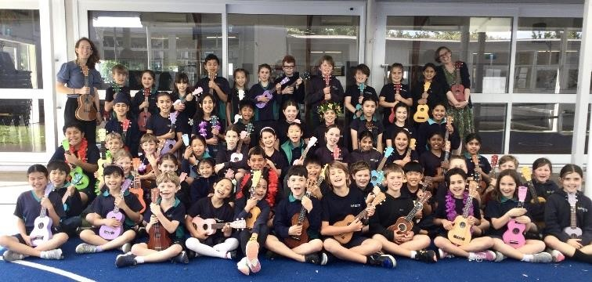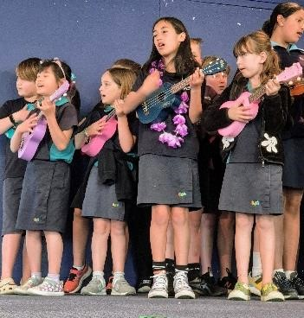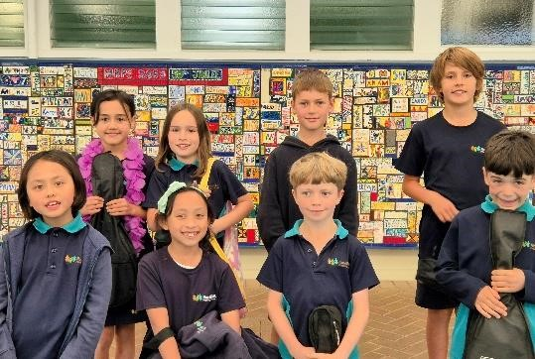

**So many happy ROPS Ukulele Musicians ready to Jam Leading our songs at the Jam Some of our newest 2024 Y3 Ukulele Players**

## School Payments Using Kindo – Our Preferred Payment Method

We are simplifying student transactions at our school with the help of Kindo, an online school payment system.

We strongly encourage our school community to use Kindo. The Kindo shop offers convenient payment options online for fees or donations, lunch orders, fundraisers, and more. It is open 24/7 so you can pay at a time that suits you. You can make full or partial payments.

New to myKindo?

myKindo is easy to set up and use. Just go to kindo.co.nz or click on this link: <https://kindo.co.nz/>:

1. Use the ‘create account’ option, to set up an account.
2. Enter in the email address the school has on file for you, and your students will automatically be added. It is imperative that your email address matches the one held by the school.

Use one family account to manage multiple students.

You can also access the online shop by visiting the school website [https://www.royaloak.school.nz.](https://www.royaloak.school.nz/) At the bottom of the Home page click on ‘Kindo’ and follow the instructions to sign up.

You can pay via American Express, Visa, Mastercard, UnionPay (fees apply), POLi or bank transfer (no fees). Add regular top ups if you’d like, then allocate to payments when you’re ready, or just pay as you go.

Already a myKindo user?

If you have used 'Kindo' or 'ezlunch' at another school, you can log in to your existing account and update your details.

1. Log in to myKindo.co.nz.
2. Select the 'My Details' page and add a new student to your account or edit an ‘existing student’ details.
3. A student can belong to two or more schools or organisations. Just select 'add membership' to the student and select our school from the dropdown list.

myKindo app

Search 'myKindo" app on Google Play or the App Store to download.

Have Questions?

Visit support.mykindo.co.nz or click on this link:

[https://support.mykindo.co.nz/portal/en/kb/https-desk-zoho-com-portal-tgcl-en-kbcustomersupport](https://support.mykindo.co.nz/portal/en/kb/https-desk-zoho-com-portal-tgcl-en-kb-customersupport) or phone 0508 454 636 for assistance - Available 8am-4pm on school days.

### Parent Group

Parent Group meetings are held on the first Wednesday of each month in the staffroom. They begin at 7pm. You are all welcome to come along. It is a great way to meet other parents from our wonderful community. The next meeting will be on Wednesday 04 December at 7pm in the staffroom.

### Secondhand Uniforms

Our next second-hand uniform sale will be at 8.30am at the Chandler Ave entrance on Tuesday 10 December.

#### Board Notice

In the last month, the board has received our School Evaluation Report from ERO (the Education Review Office). ERO is a government department that maintains a regular review program to evaluate and report on the education and care of young people in schools. The School Evaluation Report is a document that provides information about a school's performance and improvement, including what the school has achieved for its students and its future priorities. Our School Evaluation Report from ERO can be found here: [ROPS ERO Report](https://www.royaloak.school.nz/our-school/ero-report/)

The board would like to thank the SLT and staff, who worked with ERO to ensure the report provides an accurate and comprehensive reflection of the school's operations, ongoing developments, and achievements. The report provides a broad overview, highlighting the school's strengths and opportunities for growth.

For more information on how ERO reviews schools click here: [How ERO Reviews Schools](https://ero.govt.nz/how-ero-reviews/schoolskura-english-medium/school-evaluation-indicators) Our next board meeting is on December 16, 2024. We welcome whānau to attend our board meetings – these are an opportunity to understand the inner workings of our kura in more depth and stay informed on the current developments at ROPs.

**What’s coming up?**

Please do check the calendar in each newsletter as sometimes events do change.

|  |  |  |  |  |  |  |  |  |  |  |  |  |  |
| --- | --- | --- | --- | --- | --- | --- | --- | --- | --- | --- | --- | --- | --- |
| **Week 6** | 18  **Ukulele Jam**  **2024**  **Mt Roskill**  **Primary**    **Board meeting** | 19  **Oaks Athletics** | 20  **Oaks Athletics**  **Finals 10 -11**  **(postponed)** | 21  **ROI Orientation Day for Year 6s attending** | | | | 22 | | | | | |
| **Oaks Athletics** | | |  |
| **Finals 1.30** |  | |
| (rescheduled) | |  |
| Violin Lessons  (in Lieu all Day | |
| **Week 7**    Music Week  2024 | 25  Year 0 enrolments starting day Lunchtime  (Uke) Concert | 26  Lunchtime  (Oakestra)  Concert | 27  Lunchtime  Concert  (Recorders) | 28  End of Year  Choral Showcase  Combined  Vln/Cello Rehearsal 3-4 Pōhut. | | | | 29 **Unveiling and blessing of the Centennial**  **mural –7.30am**    End of Year  Instrumental Showcase | | | | | |
| **Week 8**  December | 02  **Remuera Zone**  **Athletics** | 03 **Rd Patrol training**  **9.00-11.00** **Acorns Athletics day** | 04  Last Violin  Lesson of 2024  **Parent Group**  **7.00pm** | 05  **Acorns Athletics**  **(Saving day**) **Non – uniform day collection for Jolly Jars** EPro8 Semi Final  (Team 1) 9.00-  1.00 at ANI | | | | 06  **School Assembly**  **Kindness cup**  -Last Cello  Lesson of 2024 | | | | | |
| **Sun 8 Dec** | | |  | | |
| **Term 4 String** | | | | |  |
| **Recital** |  | | | |
|  |
| **Week 9** | 09 | 10 | **11** | 12 | | | | 13 | | | | | |
|  | 9.00am Year 46 Certificate  Assembly    **Parent Helper morning tea** **10.30 - 11.30am**  **Staffroom** | Second hand uniform sale Patrols Picnic  12.00 in hall |  | **9.00am Awards**  **Assembly**    **Tamariki to visit classes for 2025**  **2pm – 2.30pm** | | | | **Oaks Pools Trip to Onehunga**  **pools**    **Junky Monkeys for Acorns** | | | | | |
| **Week 10** | 16    **Board meeting** **6pm Staffroom** | 17  **9.00am**  **Graduation**  **Assembly**  **Leavers Lunch** | 18  **Reports to go**  **home** | 19 | | | | 20 | | | | | |
| **12pm School** | | | |  | |
| **Finishes** | |  | |
|  | |

Have a happy fortnight.

Ngā mihi nui

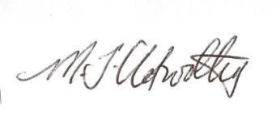

Megan Clotworthy meganc@rops.school.nz

**Community Notices**



